**Structural Design Patterns -**

Adapter Pattern -

Adapter pattern works as a bridge between two incompatible interfaces. This type of design pattern comes under structural pattern as this pattern combines the capability of two independent interfaces.

This pattern involves a single class which is responsible to join functionalities of independent or incompatible interfaces. A real life example could be a case of card reader which acts as an adapter between memory card and a laptop. You plugin the memory card into card reader and card reader into the laptop so that memory card can be read via laptop.

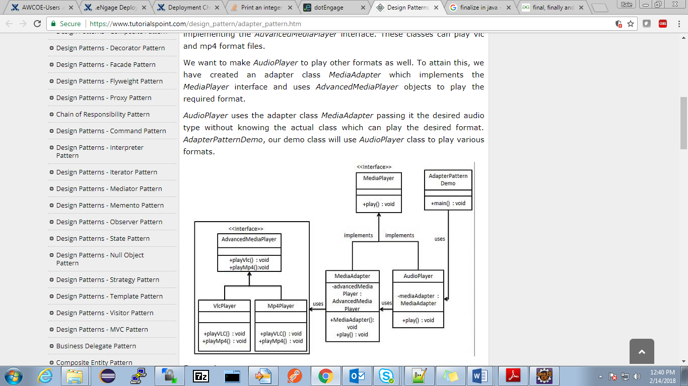

Flyweight pattern -

Flyweight pattern is primarily used to reduce the number of objects created and to decrease memory footprint and increase performance. This type of design pattern comes under structural pattern as this pattern provides ways to decrease object count thus improving the object structure of application.

Flyweight pattern tries to reuse already existing similar kind objects by storing them and creates new object when no matching object is found. We will demonstrate this pattern by drawing 20 circles of different locations but we will create only 5 objects. Only 5 colors are available so color property is used to check already existing *Circle* objects.

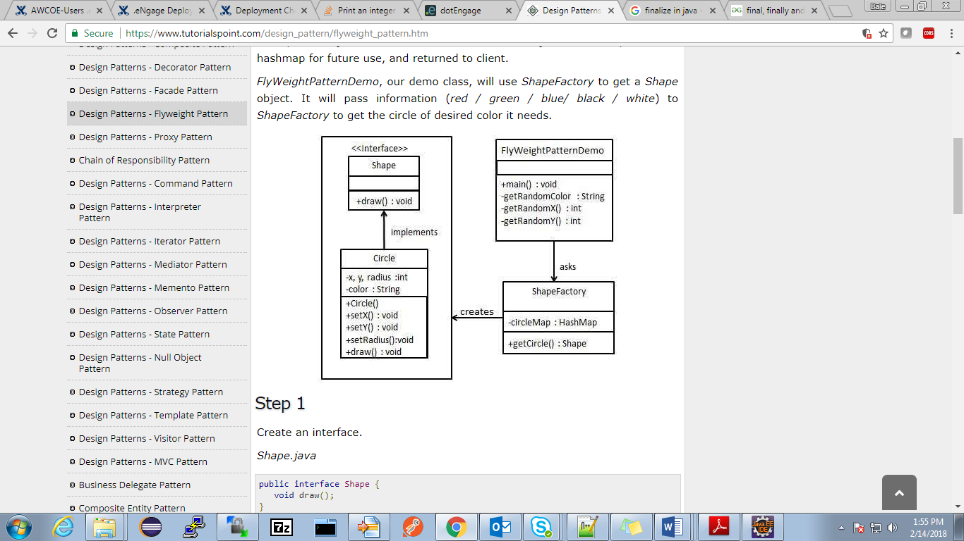

Decorator pattern -

Decorator pattern allows a user to add new functionality to an existing object without altering its structure. This type of design pattern comes under structural pattern as this pattern acts as a wrapper to existing class.

This pattern creates a decorator class which wraps the original class and provides additional functionality keeping class methods signature intact.

We are demonstrating the use of decorator pattern via following example in which we will decorate a shape with some color without alter shape class.

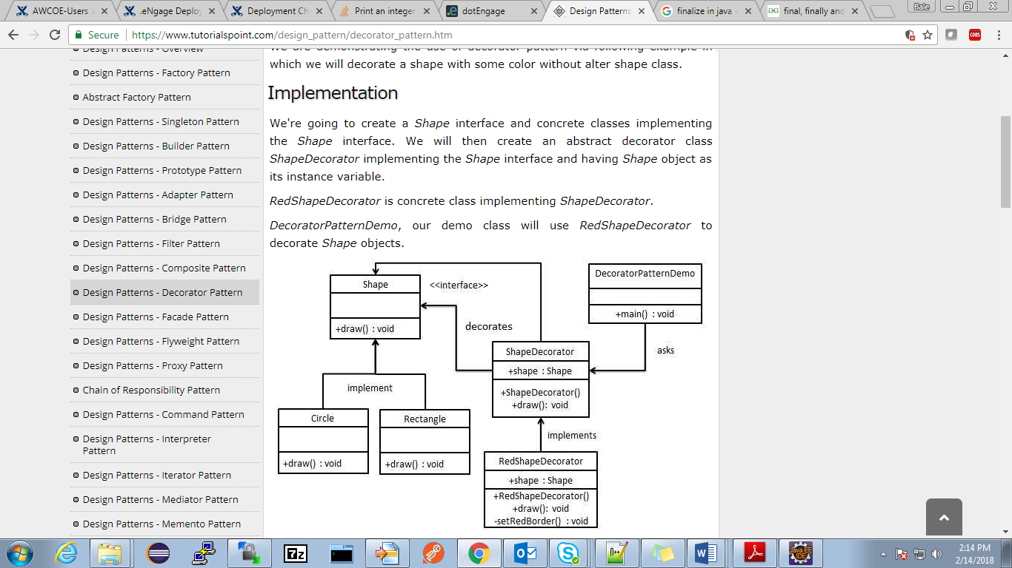

Facade pattern -

Facade pattern hides the complexities of the system and provides an interface to the client using which the client can access the system. This type of design pattern comes under structural pattern as this pattern adds an interface to existing system to hide its complexities.

This pattern involves a single class which provides simplified methods required by client and delegates calls to methods of existing system classes.

